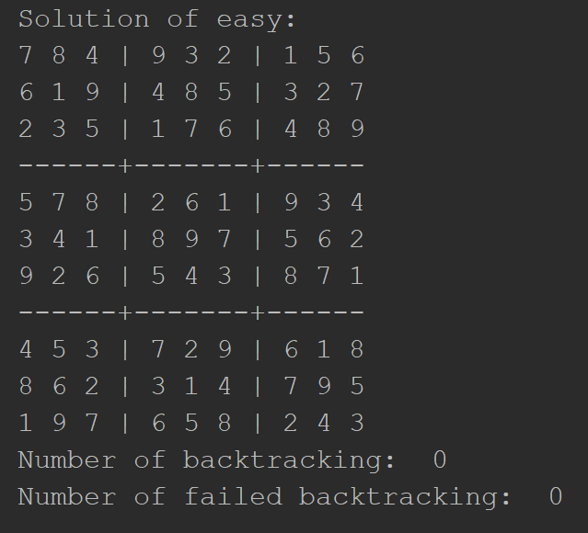 Full success for the backtracking search

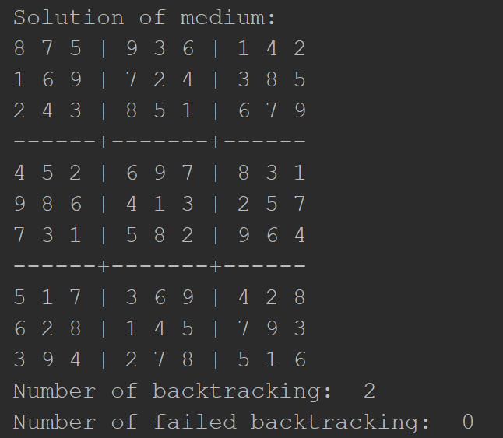 Had to backtrack a couple of times because the variable had no legal moves to assign.

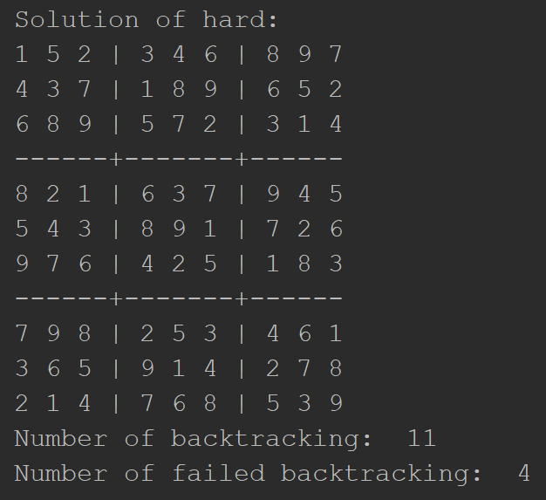 As the board getting harder, the number of failed backtracks increases and it also takes more time to solve the board.

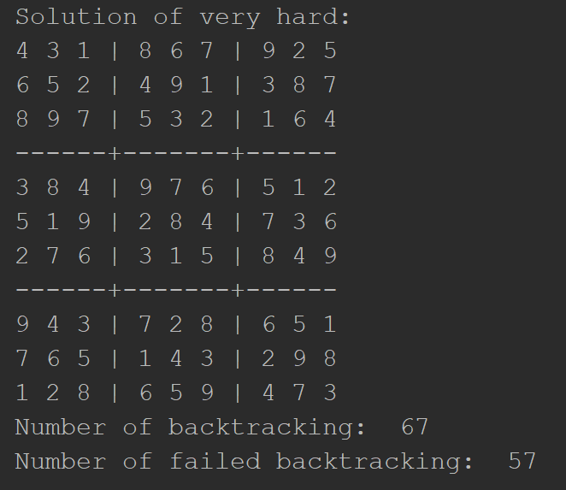 As it gets harder and harder both backtracking and failed backtracking increases. This means that the computational of the board takes more time to solve.